Section I: Multiple choice questions
- Compared to cold water, warm water:
- moves down away from the surface of the ocean
- is dense.
- is heavy.
- moves up towards the surface of the ocean.
[1 mark]
- The ocean is becoming more acidic because:
- it is absorbing more atmospheric carbon dioxide.
- deforestation allows more acidic minerals to flow into the water.
- the melting ice caps are full of weak acids.
- fish and marine life are dying and decomposing due to climate change.
[1 mark]

- What is the name of the part of the hydrosphere that is made up of frozen water?
- icecaps
- icosphere
- permafrost
- cryosphere
[1 mark]

- The most damaging effect of the permafrost melting would be:
- having nowhere to ski anymore.
- sea levels rising due to the extra water.
- massive changes to the world’s tides.
- the release of large amounts of carbon into the atmosphere.
[1 mark]

- The biosphere is not made up of:
- bacteria.
- plants.
- animals.
- asteroids.
[1 mark]

- In which of Earth’s spheres is the most oxygen stored?
- hydrosphere
- atmosphere
- biosphere
- lithosphere
[1 mark]

- The most common gas in the atmosphere is:
- nitrogen.
- carbon dioxide.
- oxygen.
- hydrogen.
[1 mark]

- The crust of the Earth is broken into a number of pieces called:
- tectonic plates.
- boundaries.
- continents.
- ridges.
[1 mark]

Section II: Short answer questions
- What are the Earth’s four major spheres?
[2 mark]

- Give three negative effects of melting sea ice.
[3 mark]

- Give two ways in which humans have contributed to the enhanced greenhouse effect (2marks)

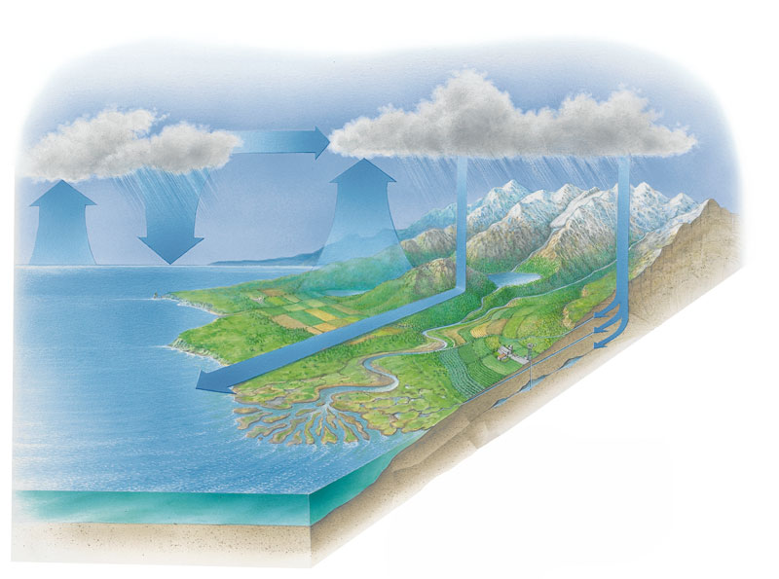
- On the diagram above, list the main stages of the water cycle.
[4 marks]

